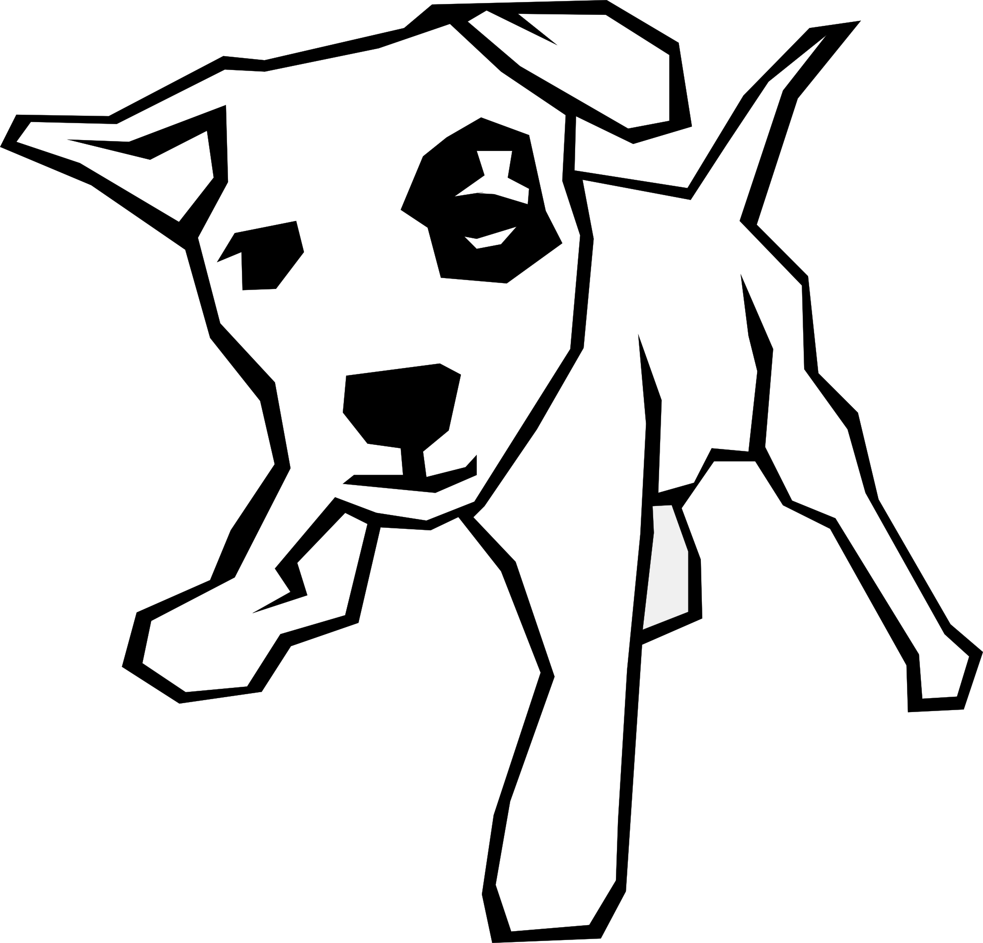
Language Features - 3 Way Match
Match the name with the definition and example.
Language Feature Name |  | Definition |  | Example
rhetorical question |  | A polite way of saying something bad |  | It’s raining cats and dogs  so don’t step in a poodle.
simile |  | First letter matches in words close to each other |  | ‘I feaed the worst’ rather than ‘I thought I might die.’
alliteration |  | A dry joke. |  | Reach the feet in the street
adjective |  | Two opposite words put together |  | Am I thirsty?
euphemism |  | Compares using the word ‘like’ or ‘as’ |  | Ethan is like a rock.
assonance |  | Describes a noun |  | She had shut the door a million times that day.
pun |  | A question that doesn’t require an answer |  | Deadly doors don’t die.
metaphor |  | Extreme exaggeration |  | The red barn.
juxtaposition |  | Compares without using the word ‘like’ or ‘as’ |  | Snow was like the frosting on a cake.
hyperbole |  | The rhyme inside the words |  | That man is a dog.
Language Features - 3 Way Match
Match the name with the definition and example.
Language Feature Name |  | Definition |  | Example
rhetorical question |  | A polite way of saying something bad |  | It’s raining cats and dogs  so don’t step in a poodle.
simile |  | First letter matches in words close to each other |  | ‘I feaed the worst’ rather than ‘I thought I might die.’
alliteration |  | A dry joke. |  | Reach the feet in the street
adjective |  | Two opposite words put together |  | Am I thirsty?
euphemism |  | Compares using the word ‘like’ or ‘as’ |  | Ethan is like a rock.
assonance |  | Describes a noun |  | She had shut the door a million times that day.
pun |  | A question that doesn’t require an answer |  | Deadly doors don’t die.
metaphor |  | Extreme exaggeration |  | The red barn.
juxtaposition |  | Compares without using the word ‘like’ or ‘as’ |  | Snow was like the frosting on a cake.
hyperbole |  | The rhyme inside the words |  | That man is a dog.

